I. Introduction

The vector network analyser(VNA) analyses the s-parameter and has two ports, denoted S11, S12, S21 and S22. S11 represents the reflected signal transmitted from port 1 and received by port 1. S21 represents the transmission coefficient transmitted from port 1 and received by port 2. Most networks S21 and S12 are equal, which means that the network is a reciprocal network.

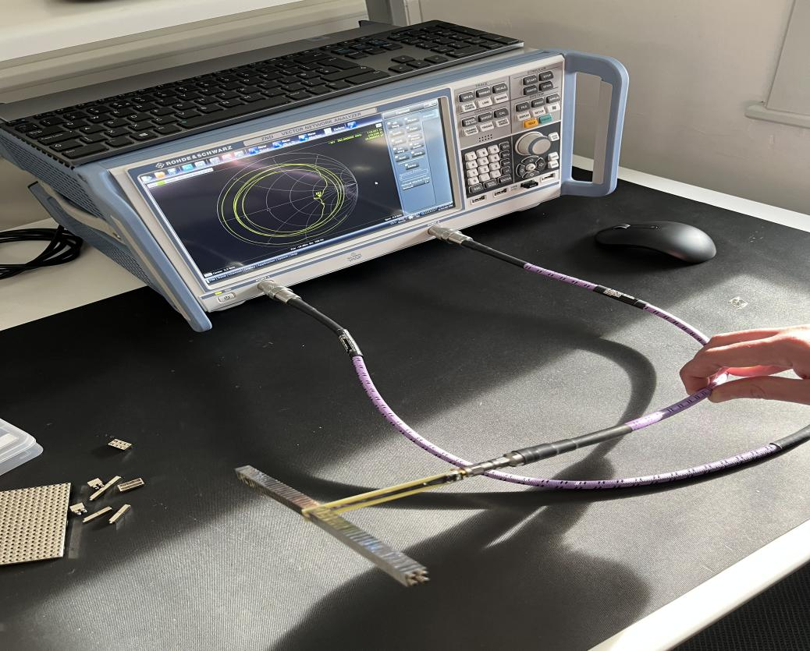

Figure 1: Vector Network Analyser(VNA)

II. Specific experiments.

1. Connection of antenna and vector network analyzer

The connection ports are all 3.5mm in size, the higher the frequency the more expensive the connection port is required. The connection port consists of the metal on and inside the conductor inside the hole, and the metal layer outside. For male and female connections, we need to insert the male connector into the female connector and then only rotate the external metal layer of the male connector, do not try to twist the female connector.

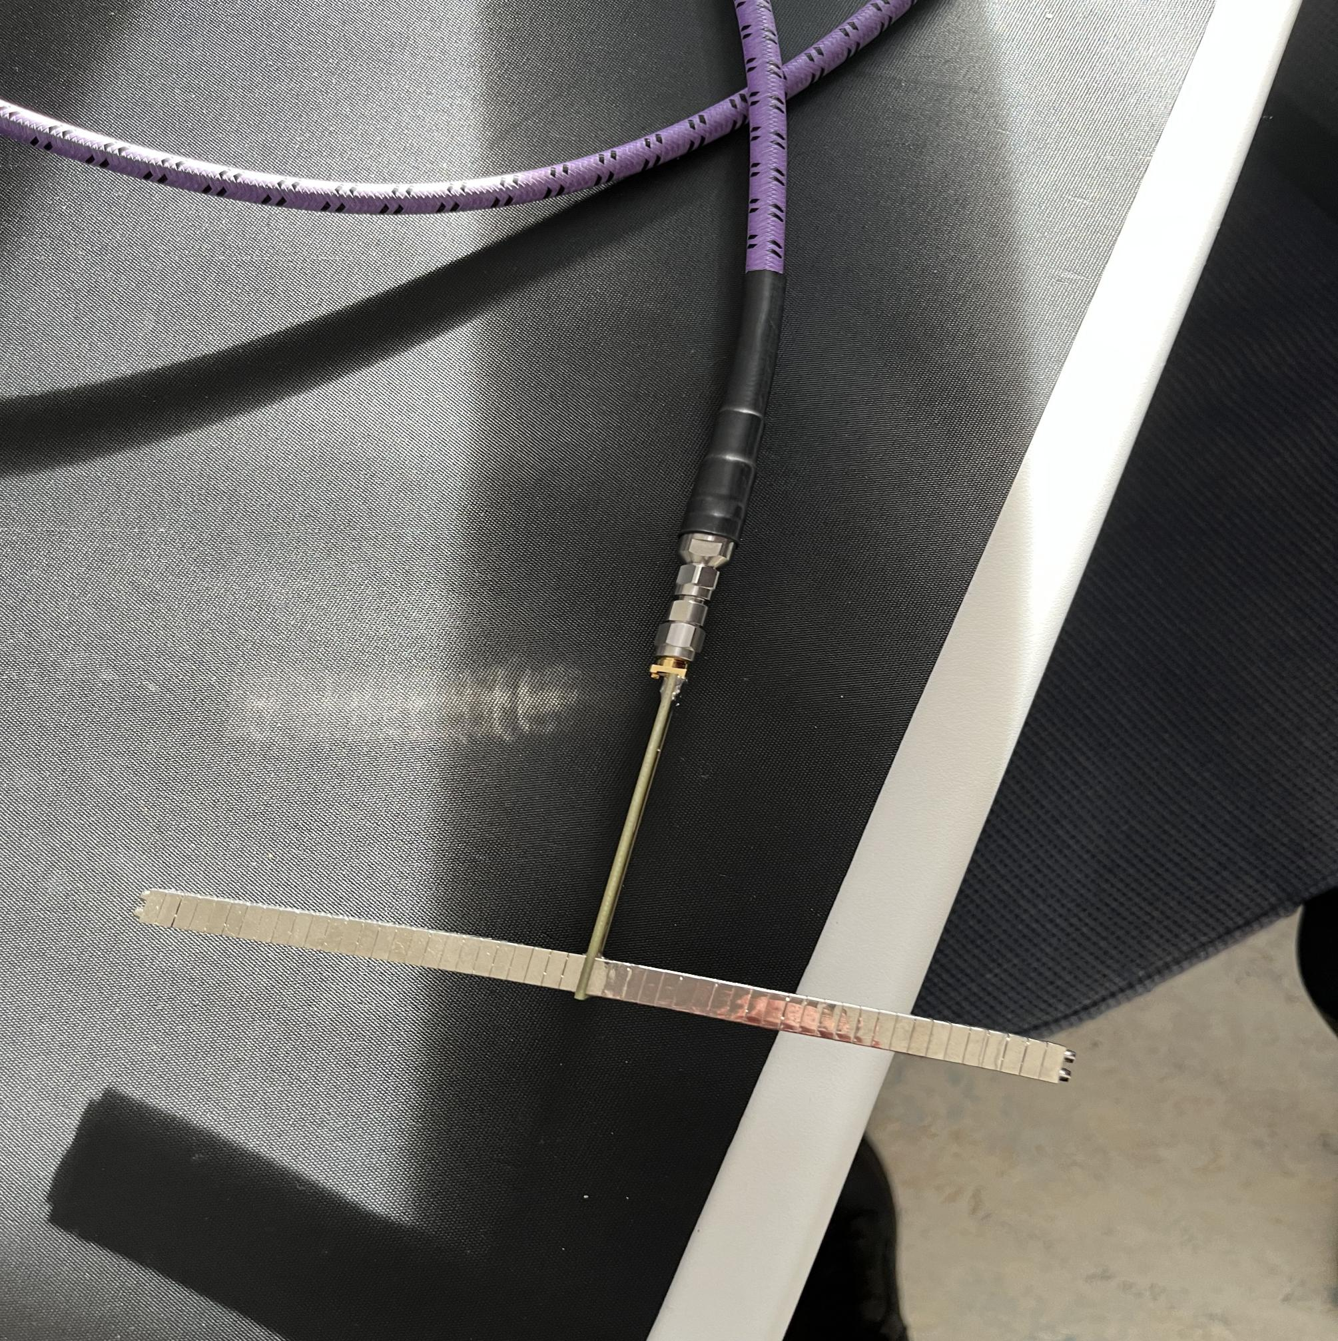

Figure 2: Connection of antenna and vector network analyzer

2. Calibration

Single port calibration usually has three matches: open, short and load

When connected to open, you get 100% reflection, at which point dB is zero. A flat line at zero is shown.

When connected to a short circuit, the inner and outer conductors are connected. All signals are reflected and a flat line at zero is obtained.

The match means that everything is transmitted, so you get a very low reflection coefficient.

Multi-port calibration also requires straight-through measurements. For example two ports is a through connection one to two, three ports is one to two, one to three, two to three, and so on.

Calibration generally needs to be carried out before, or even during and after validation. This experiment calibration does not affect as much as other experiments.

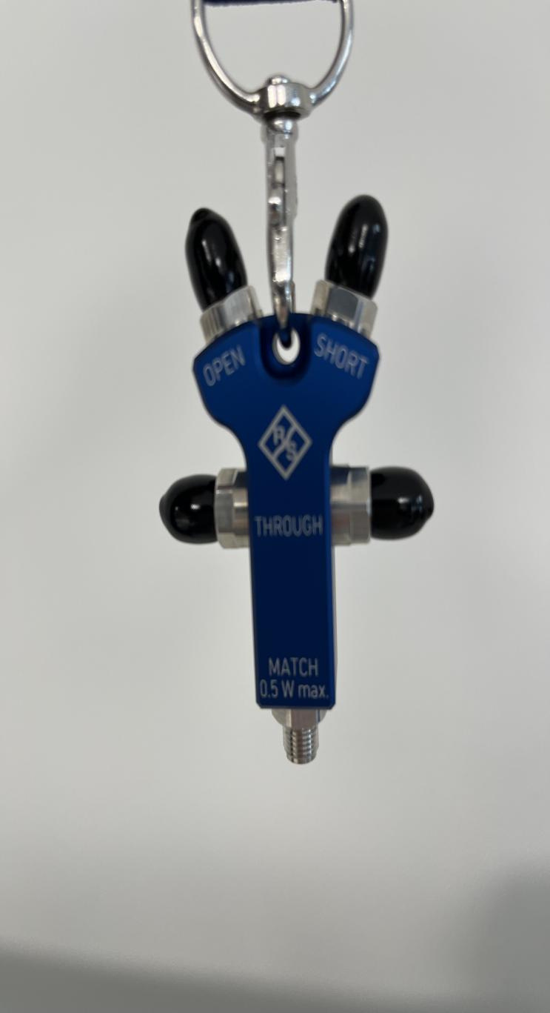

Figure 3: Calibration

3. Measurement

dB is a measure of the relationship between the gain or attenuation of two values. And dBm is relative to one milliwatt. For example, if the screen shows -10 dB and the outgoing signal is 10 dBM, the actual value is -20 dBM. The port transmits a sine wave and the reflected sine wave is measured and Fourier transformed to obtain the amplitude and phase plotted on the screen. The display shows the units in dB, if it is 0 at this point it means there is no loss. The power emitted and received is the same. This means that the signal radiates out. The antenna needs the energy to radiate out when it is operating and needs to measure below -10 DB.

The frequencies taken for this experiment are from 100 MHz to 2 GHz, which is the frequency range that can reach the depth of the body you want to test without causing a high level of damage. The scanning frequency depends on the accuracy of the measurement required. It represents the number of points between the low end and the high end. A high frequency allows the scan to be repeated over and over again and averaged over time. Therefore the more points the longer it takes, the less noise and the more accurate it is.

4. Antenna mounting

It can be mounted directly by hand and removed by using plier on the four corners.

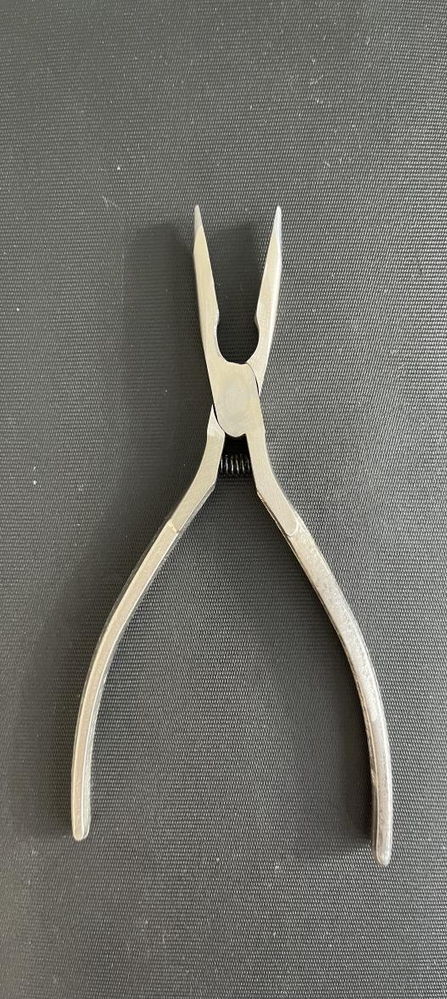

Figure 4: Plier

III. Data analysis

Calculation of resonant frequency

1.For dipole antenna, the resonant frequency is calculated as follows

$L=(3*n+2)*2+1.5$) \* 10 ^ ( - 3)

First calculate the length of the antenna, where the length of each metal block is 3+2, 2 is the part that overlaps with other metal blocks. 1.5 is the Balun height. n is the number of metal blocks on one side.

Next, calculate the resonant wavelength of the corresponding antenna

$$λ = 2L$$

for a dipole, resonance occurs when the antenna length is half the wavelength.

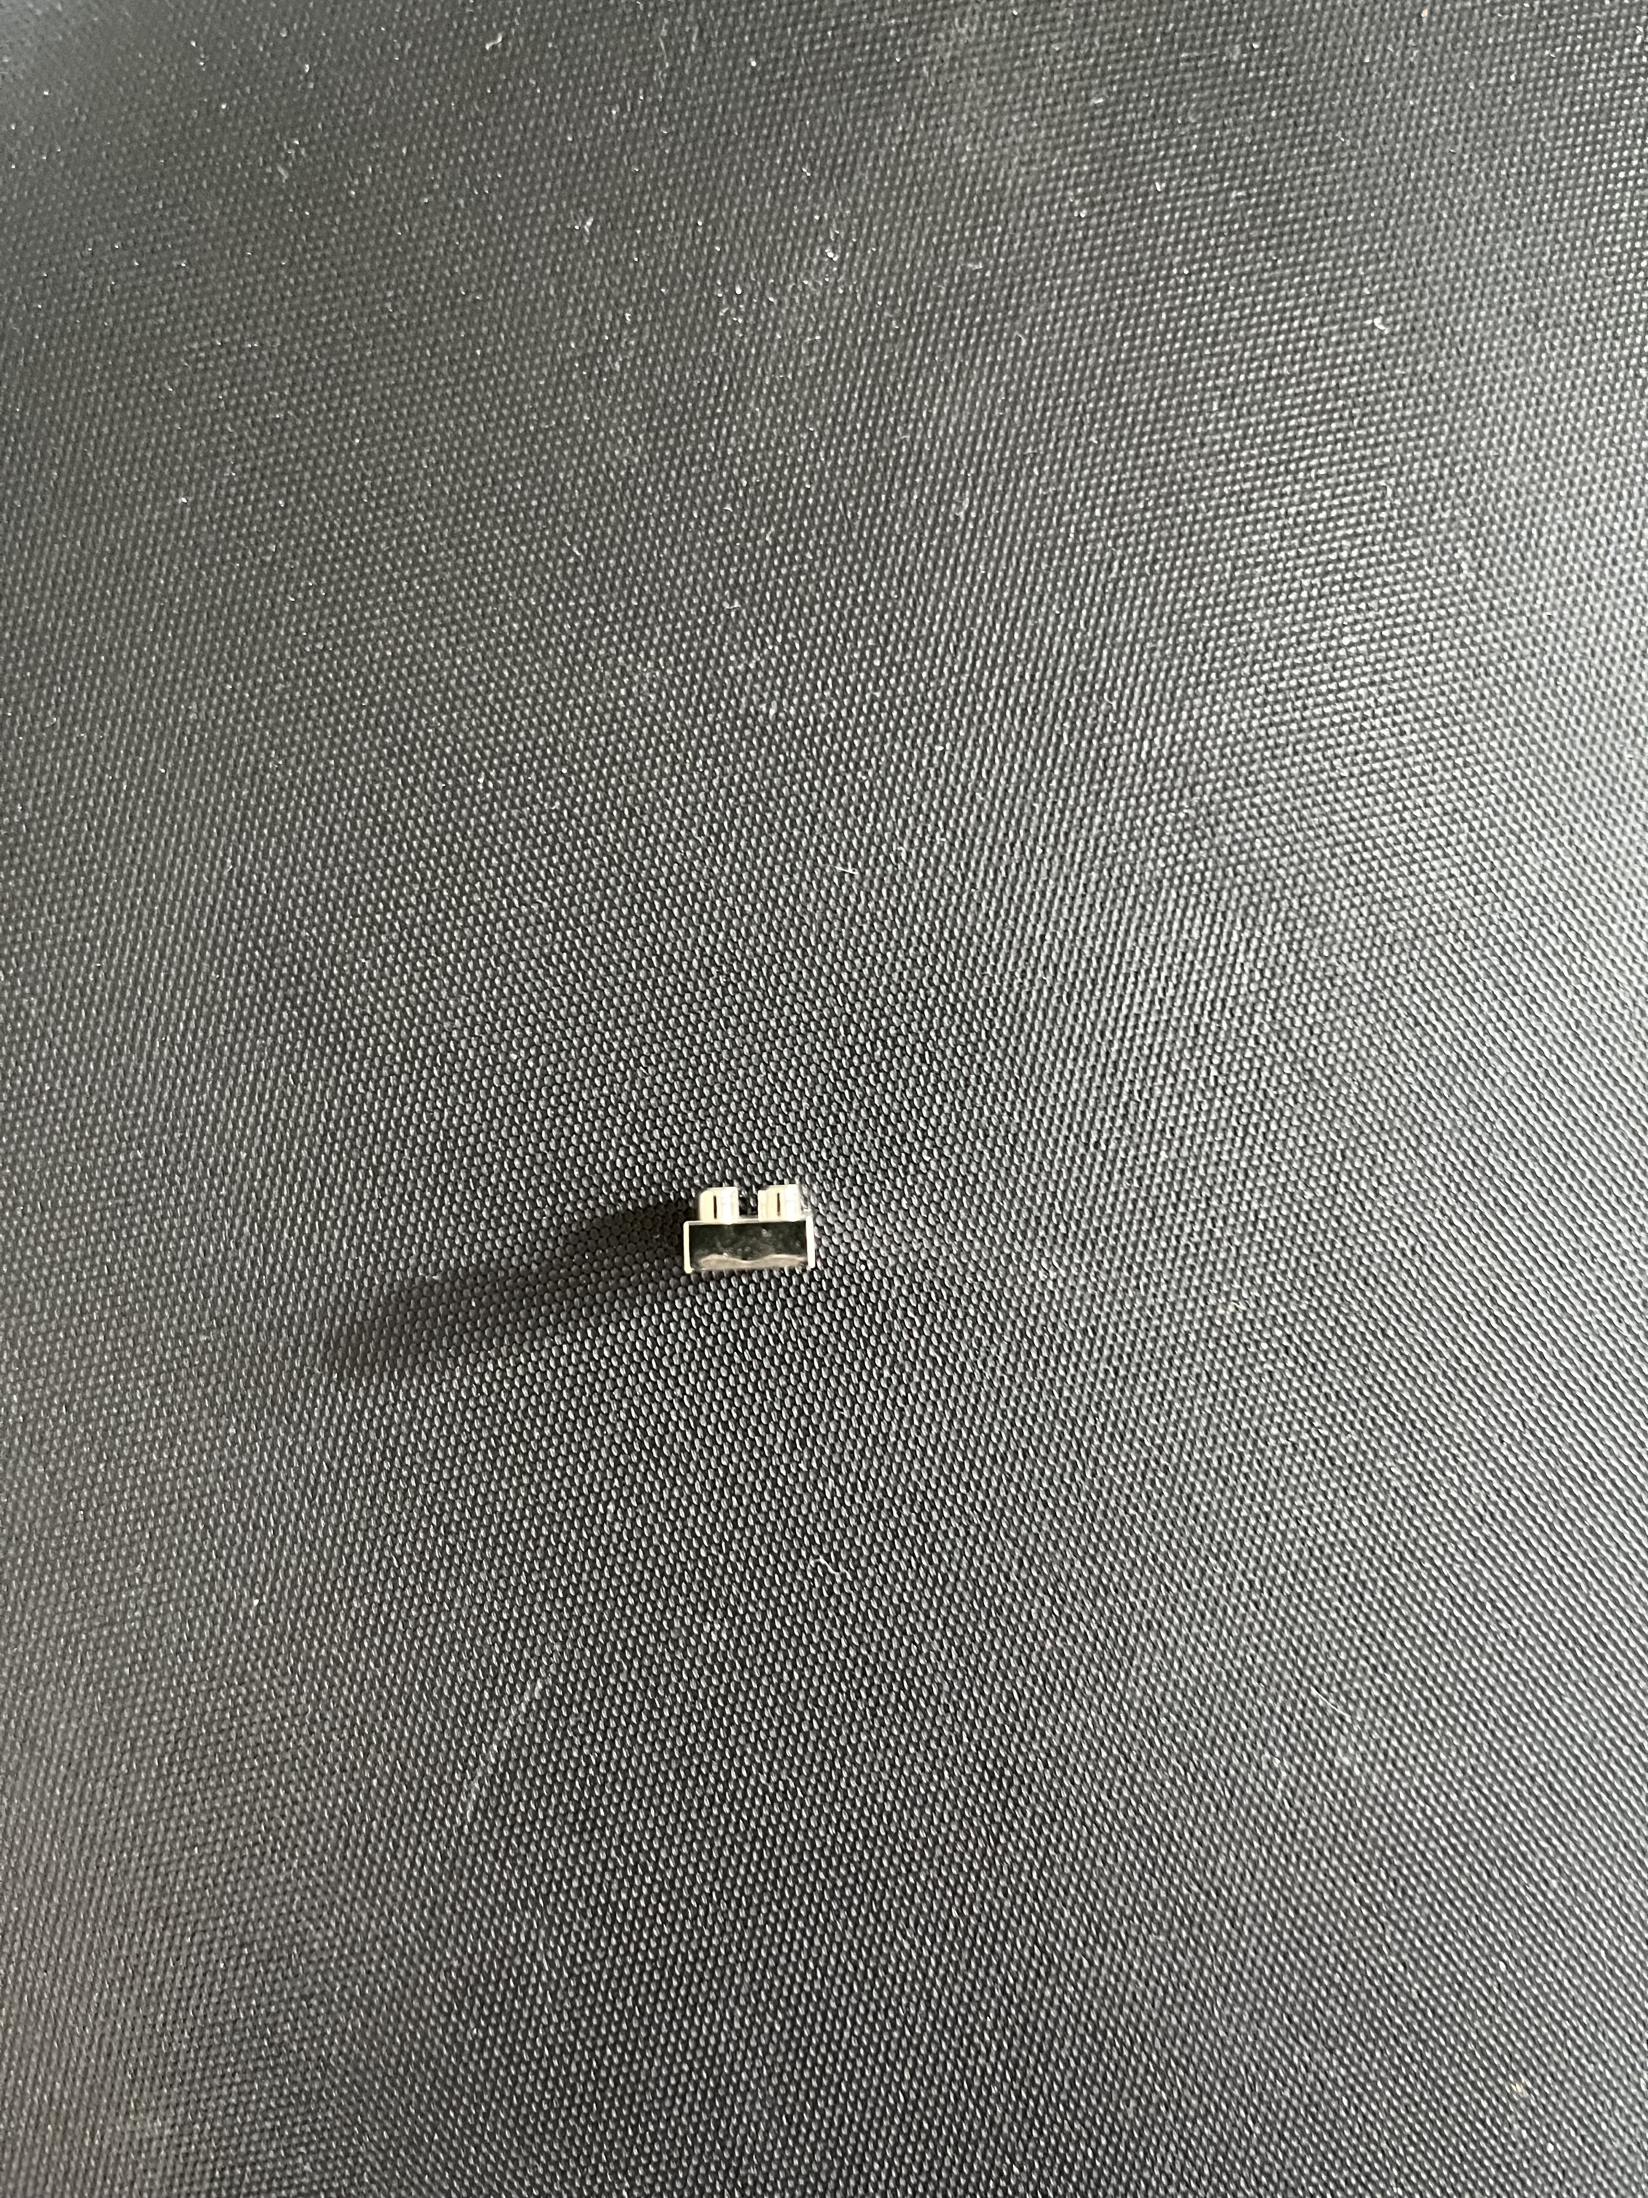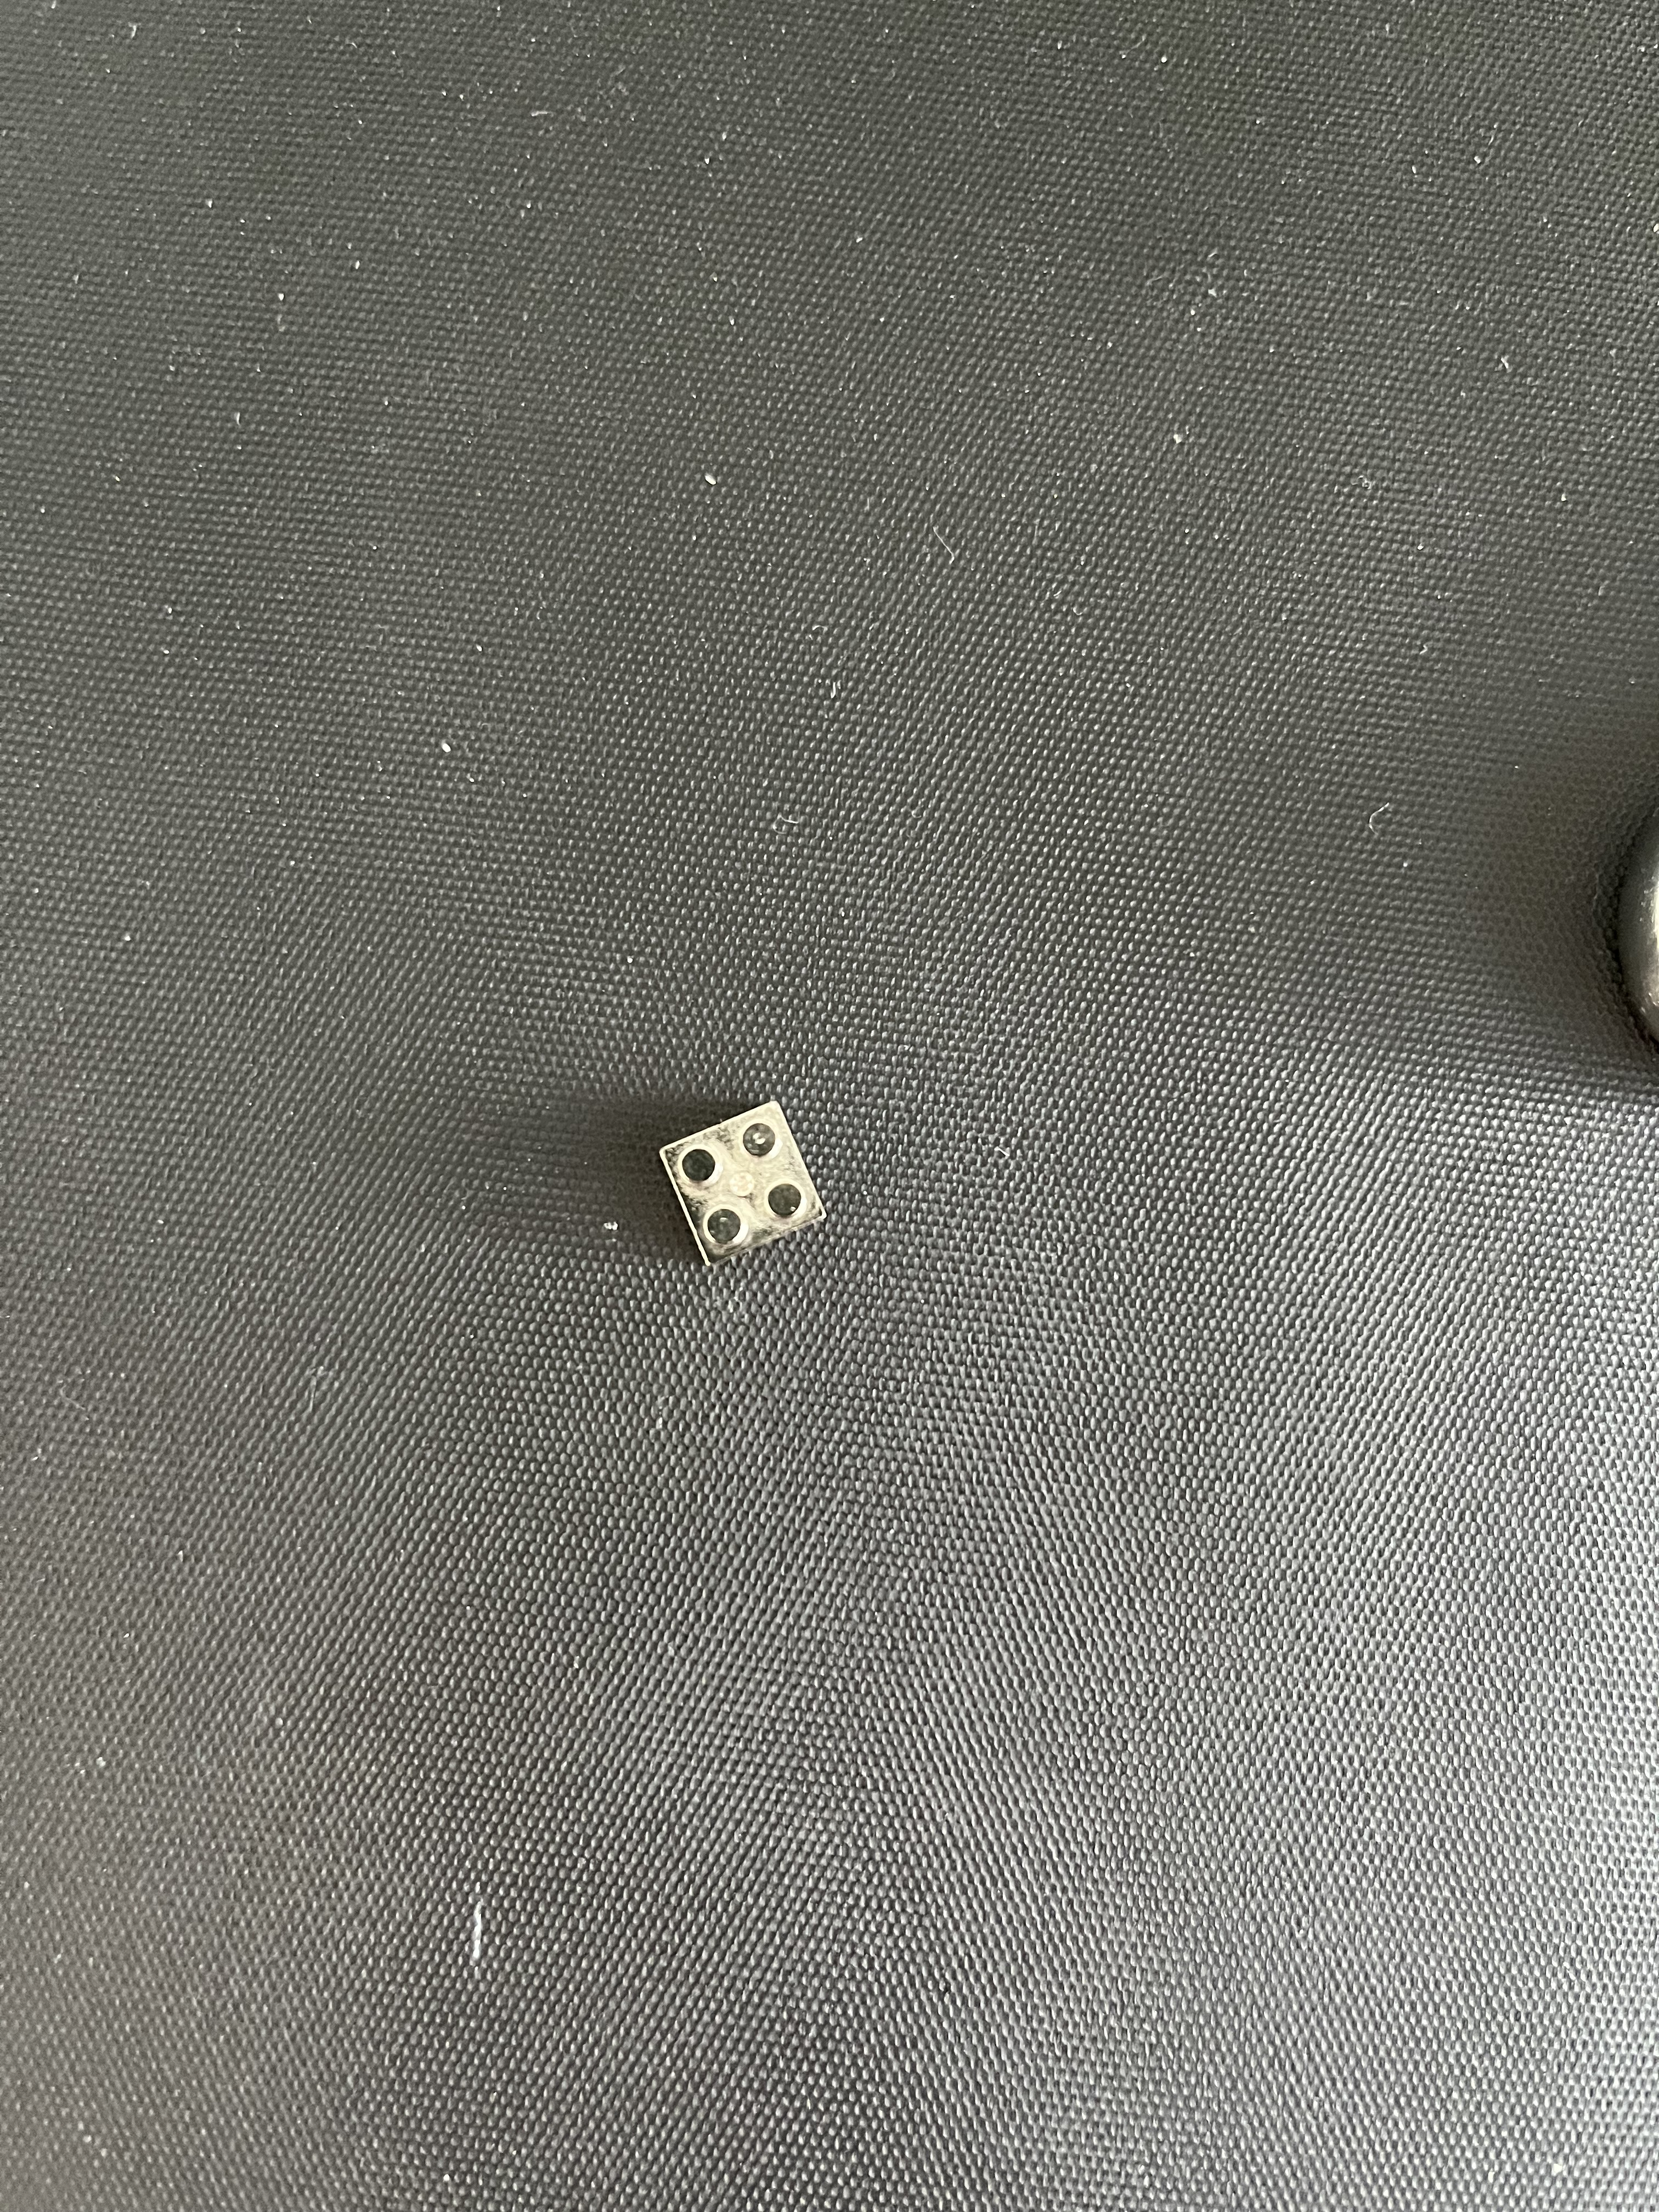

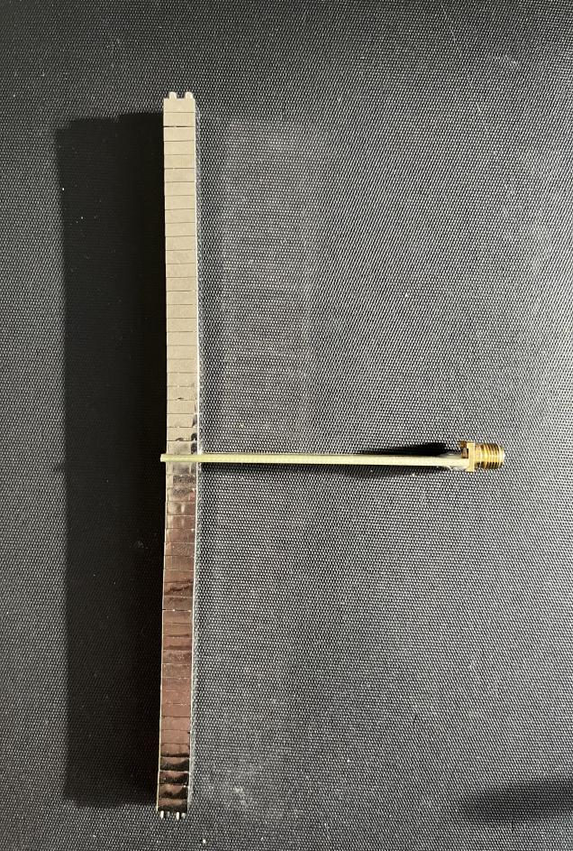

Figure 5: Materials for Dipole Antennas

2.For thick monopole antenna, the resonant frequency is calculated as follows

First calculate the length of the antenna

$L = (3 ∗ n + 2 + 3$) \* 10 ^ ( - 3)

where the length of each metal block is 3+2, 2 is the part that overlaps with other metal blocks. n is the number of metal blocks. And the length of the bottom block 3.

Next, calculate the resonant wavelength of the corresponding antenna

$$λ = 4L$$

For a monopole antenna, resonance occurs when the antenna length is one quarter of the wavelength.

3.For thin monopole antenna, the resonant frequency is calculated as follows

$$L = (9 * n + 3 + 5) * 10 ^ ( - 3)$$

First calculate the length of the antenna, where the length of each metal block is 9. The bottom metal block has a length of 3 and the top metal block has a length of 5.

Next, calculate the resonant wavelength of the corresponding antenna

$$λ = 4L$$

For a monopole antenna, resonance occurs when the antenna length is one quarter of the wavelength.

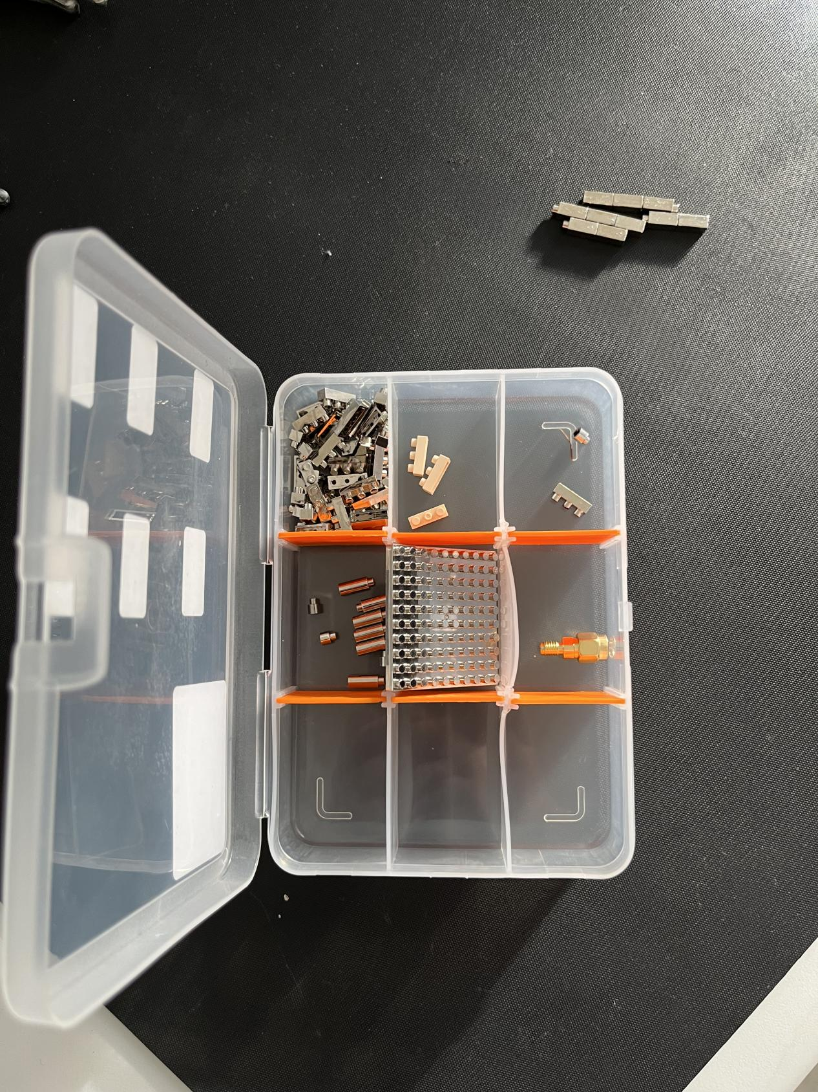

Figure 6: Materials for Monopole Antennas

Finally we calculate the expected resonant frequency, according to

$$f = c/λ$$

c is the speed of light.